**GIT Notes**

Git & GitHub Crash Course For Beginners

<https://www.youtube.com/watch?v=SWYqp7iY_Tc>

// This will give you your GIT version on your PC. This will work with Windows cmd.exe and GitBash

git --version

// To set user name and email

git config –global user.name “Joseph Griecci”

git config –global user.email “jgriecci@hotmail.com”

// To see all configuration settings.

git config --list

// This will tell you what is in the staging area.

git status

// Adds all the files in the directory (dot is current directory)

git add .

// Do a git status again to see the file color change from red to green.

git status

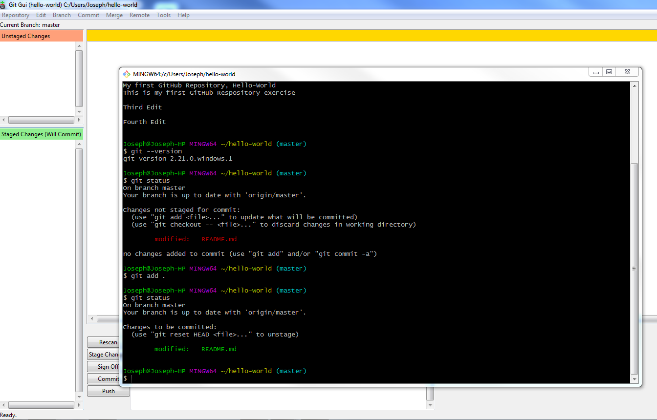

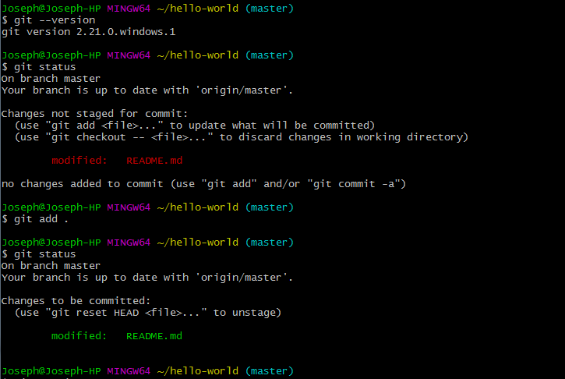

// Do a git commit and then enter a commit message, when you save it you will see the following.

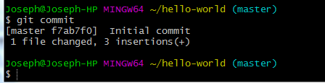

// Note: you can skip editing the commit window by doing the following command. It does the same as the previous git commit, except you do not go into the editor to add the commit message.

git commit -m ‘Change Readme file’

// To ignore files, you do not want to commit, add them to .gitignore

Git Tutorial for Beginners: Command-Line Fundamentals

<https://www.youtube.com/watch?v=HVsySz-h9r4>

**Initialize a Repository from existing code**

git init -- to start tracking project in directory

rm -rf .git --to stop tracking project in the directory

git status

touch .gitignore --create a text file to hold files and directories to ignore

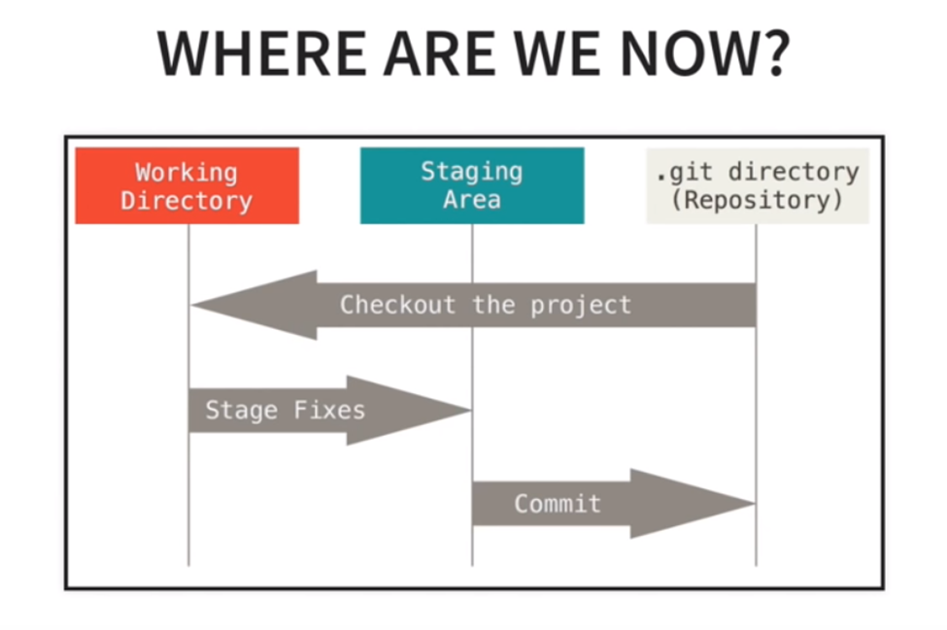

git add -A --Add all files to staging area from Working Directory

git status

git reset <filename> --removes file from staging area

git reset --removes all files from staging area

git commit -m “Initial Commit” --Commit changes to Staging area

git status

git log

**Cloning a Remote Repository**

git clone <url> <where to clone>

git clone <https://github.com/jgriecci/hello-world.git> .

git remote -v --list location of the repository.

git branch -a --list all branches

git diff --shows changes to the code

git status

git add -A --add all changes to staging directory

git commit -m “Initial Change” --Commits changes

git pull origin master --pulls latest version from Repository

git push origin master --push changes to master branch of remote repository

**Common Workflow**

git branch --shows current branch

git checkout <branch>

git branch

**Derek Banas**

<https://www.youtube.com/watch?v=r63f51ce84A&list=PLGLfVvz_LVvQHO1PfyscjIPkNJjgHsLyH>

<https://www.youtube.com/watch?v=EYIvWWx1YDw&list=PLGLfVvz_LVvQHO1PfyscjIPkNJjgHsLyH&index=2>

<https://github.com/github/gitignore>

**Login to GitHub**

<https://github.com/>